**Resource Group create - 01 - 01**

Description: Script creates empty Resource Group of name: “TEST-RG”.

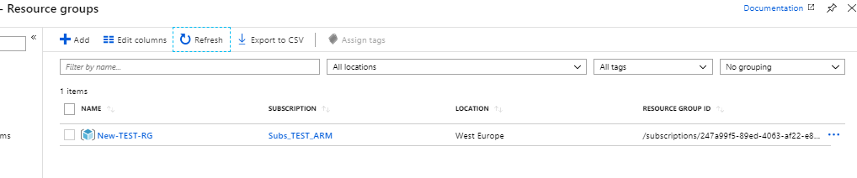

{

"$schema": "https://schema.management.azure.com/schemas/2018-05-01/subscriptionDeploymentTemplate.json#",

"contentVersion": "1.0.0.1",

"parameters": {},

"variables": {},

"resources": [

{

"type": "Microsoft.Resources/resourceGroups",

"apiVersion": "2018-05-01",

"location": "westeurope",

"name": "New-TEST-RG",

"properties": {}

}

],

"outputs": {}

}

Very important is first line which define level of ARM template – here we have subscription level on which we can create Resource Groups and of course others resources.

"$schema": "https://schema.management.azure.com/schemas/2018-05-01/subscriptionDeploymentTemplate.json#",